LABORATORIO ARTIGIANO RETI
di ARCHETTI CARLO
Reti da Pesca – Sport – Caccia
Recinzione Impianti Sportivi
Antinfortunistica – Acquacoltura
25058 SULZANO (BS) – Via Tassano, n. 8
Tel. e Fax 030/985290 – Tel. Ab. 030/985191
Cell. 328 0562071 c.f. RCHCRL64C01F532U – P.I. 03216410179
www.retiarchetti.it – info@retiarchetti.it
www.retiarchetti.com – info@retiarchetti.com
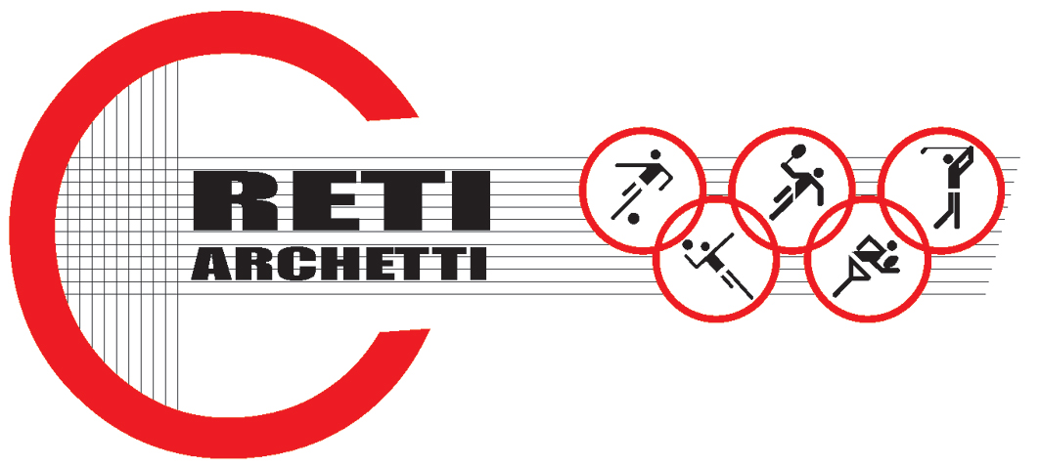

TECHNICAL DATA SHEET ART.CODE: A 25
NET MADE OF POLYETHYLENE, KNOTTED, STABILIZED AGAINST UV RAYS, MESH mm 40 x 40, THICKNESS MM 2.2

STATIC TESTS: tests carried out on a polyethylene knotted net, green colored (title 3x7x600 denier and mesh mm. 40) according to Standard EN 1263-1.
Hereafter the results obtained with tests on samples of a brand new net, dimensions 3 x 3 m:

AVERAGE ULTIMATE STRENGTH: 854 daN

Technical features

- MATERIAL: H.D. Polyethylene, stabilized against UV rays, water repellent.
- AVAILABLE COLORS: green
- YARN THICKNESS: 2,2 mm.
- NET: squared mesh
- MESH: mm. 40 x 40
- WEIGHT: g. 98/mq.
- EDGE STRIP: with a 6 mm polyethylene braid
- FUSION TEMPERATURE: 120° C
- MIN. USE TEMPERATURE: – 40° C
- WATER ABSORPTION: 0,01% - WATER REPELLENT –
- MOTH RESISTANCE = ABSOLUTE
- MOULD RESISTANCE = ABSOLUTE
- ABRASION RESISTANCE = EXCELLENT
- MINERAL ACIDS = RESISTANT
- ORGANIC ACIDS = RESISTANT
- ALKALI = RESISTANT
- OIL = RESISTANT

Each net can be manufactured with length and width on customer request. Nets are complete with a reinforced strip along the edge with a 6 mm braid sewed to the net. A piece of rope at the angles makes the installation easier.

